**Handover Document – MediaWiki Install**

**NASA EVA Gamification**

*Group 3*

**Prepared By**

Kevin Fortier

Michael Salgo

Victoria Guadagno

Okechukwu Ogudebe

Jacqueline Macfadyen

Montrell Nuble

Contents

Introduction 3

Document Overview 3

Obtaining the CentOS-7 image 3

Virtual Box 3

Software Installation 3

Extension Pack Install (Optional) 7

Creating a Virtual machine 10

Machine setting adjustments (Optional) 14

Installing CentOS-7 17

Creating a wiki with Meza 30

Additional Tips 36

|  |  |  |  |
| --- | --- | --- | --- |
| **Version Number** | **Description of Change** | **Author** | **Date** |
| 1.0 | Initial Creation of Document | Kevin Fortier | 04/7/2018 |

# Introduction

## Document Overview

This document will detail the steps needed to get a MediaWiki environment up and running on a CentOS-7 operating system. This document will also provide guidance on installing Oracle’s VirtualBox software on a Windows host system, so the CentOS-7 install can run as virtual machine. It is assumed the reader is minimally familiar with networking basics, Windows and Linux administration, and has the required permissions on their Windows host for software installation.

All screen captures are taken on a Windows 10 host machine, installing VirtualBox 5.2.8, for a CentOS-7 Build 1708 image. Future versions of the software above, may differ slightly in their presentation.

# Obtaining the CentOS-7 image

Due to the demands on bandwidth and the requirements of the Meza installer, the minimal ISO should be downloaded from <https://www.centos.org/download/>. It is advised to verify the download via checksum before using the image.

# Virtual Box

## Software Installation

This section can be skipped, if there is a host system which can directly take the CentOS-7 install. Otherwise, the VirtualBox software can be used to create a virtualized system which can run inside of a Windows host.

These steps are provided as guidance only. If problems arise during the install or alternative options are picked during install, please visit <https://www.virtualbox.org/> for additional reference.

1. Obtain Oracle VirtualBox software from <https://www.virtualbox.org/wiki/Downloads>. The guide will use the Windows hosts installation package.
2. Run the downloaded installation package. If the user on the Windows host has non-elevated privileges, the installation package should be run as an Administrator.
3. Click the Next > button on the initial Setup Wizard screen.  
   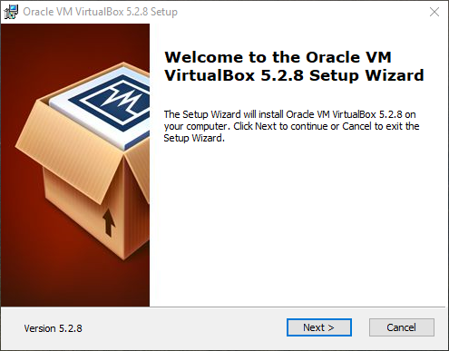
4. Leave the features to be installed as the default. Click the Browse button to select a different install location if desired. Click the Next > button when satisfied with the selections.  
   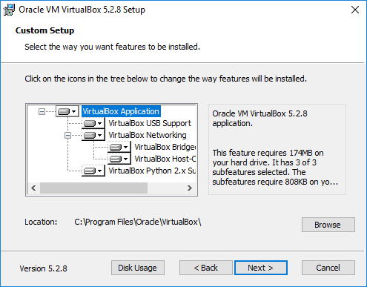
5. Select which options to additionally install, based on personal preference. It is advised to keep the “Register file associations” and “Create start menu entries” checked. Click the Next > button after making any adjustments.  
   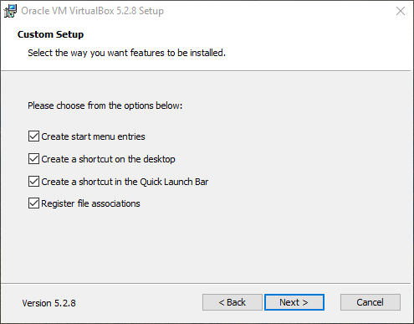
6. The software will add features related to any networking interfaces on the host machine. As a result, network connectivity may be impacted during the install. Click Yes to proceed.   
   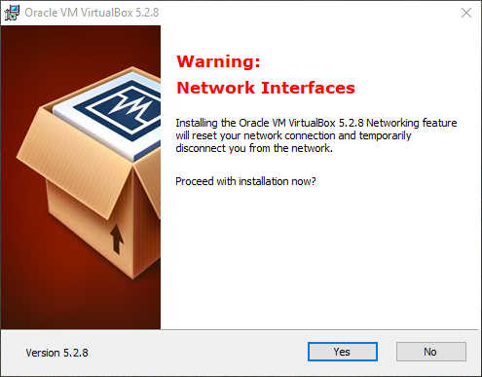
7. Click the Install button to start the install.  
   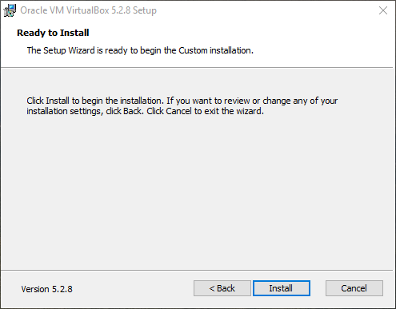
8. Windows UAC messages may appear after starting the install. Click Yes on any messages of these type to allow the installation to continue.
9. After some time, the installation will finish. Click the Finish button, which will launch the software.  
   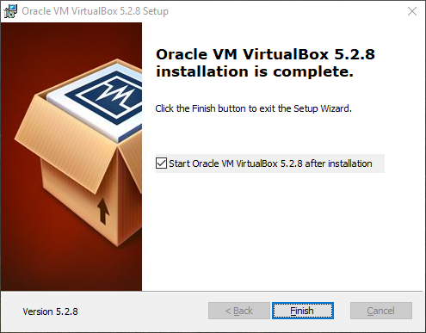

## Extension Pack Install (Optional)

While not needed for the VirtualBox software to work, it is highly advised to install the Extension Pack. It contains support for USB 2.0 and USB 3.0 devices, disk encryption, and other features which provide a better user experience, in terms of use and administration. The steps below will guide through the process of installing the Extension Pack.

1. Close the VirtualBox software, if started from the install process.
2. Go to the VirtualBox website and navigate to the Downloads page: <https://www.virtualbox.org/wiki/Downloads>.
3. Click on the link under the Extension Pack section to begin the software download. The file should end with “.vbox-extpack”.
4. After the download completes, double-clicking the file will cause the VirtualBox software to launch, if the installation used the “Register file associations” option. Otherwise, launch the VirtualBox software and navigate to File > Preferences > Extensions and click the green + icon on the right to pick the newly downloaded file.  
   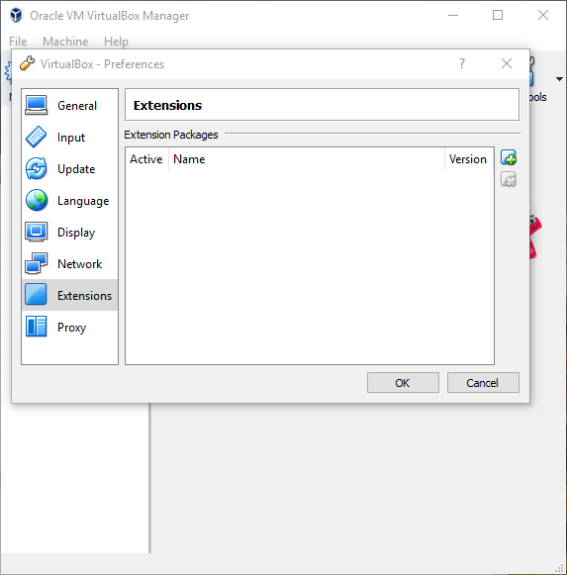
5. Click the Install button to proceed with the installation.  
   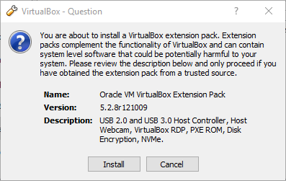
6. Scroll to the bottom of the text box and click the I Agree button on the License window.  
   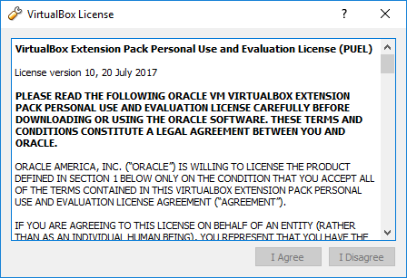
7. If any Windows UAC prompts appear, click Yes to install the software.
8. Click OK, after the extension pack has finished installing.  
   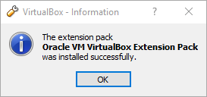

## Creating a Virtual machine

The following steps will detail how to create the CentOS-7 Virtual Machine (VM). The screen captures included below are from VirtualBox software which has the Extension Pack installed. If the Extension Pack was not installed, some options may not be available.

1. Start the VirtualBox software if not already running. Insure that the software is in Machine Tools view.  
   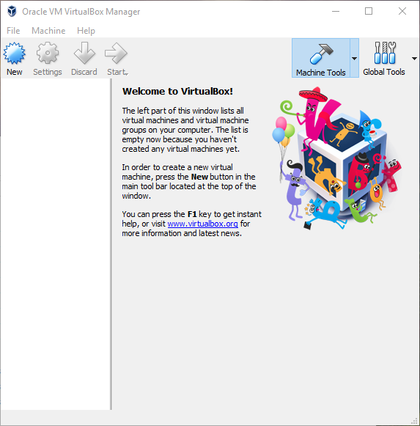
2. Click on the New button. Give the VM a name and select “Linux” for Type and “Other Linux” for Version. Pick 64-bit if running a 64-bit host OS. Click the Next button when done.  
   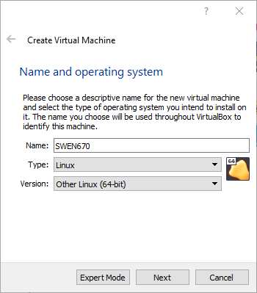
3. Adjust the memory size to give to the VM. This setting will be highly dependent on the total memory of the host system. Recommend a value of 1024MB, if the host machine has at least 4GB of RAM or higher. Click Next after adjusting the value.  
   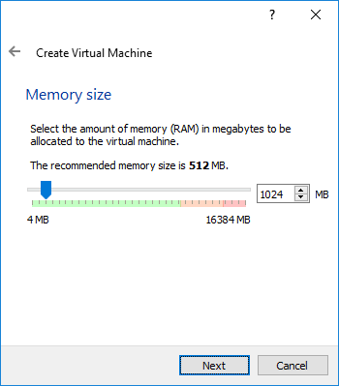
4. The recommended size of 8.00GB is sufficient. The value can be increased if desired. Make sure the “Create a virtual hard disk now” option is selected and click the Create button.  
   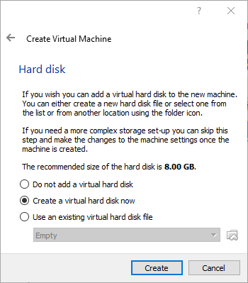
5. The default VDI disk file type can be selected. Other options can be used if more familiar with different virtual machine software. Click Next to continue.  
   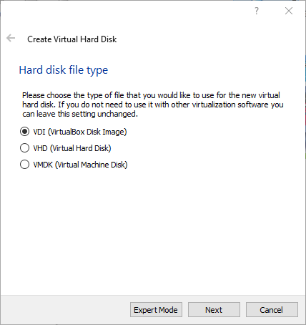
6. It is recommended to use the “Dynamically allocated” option. This will keep the footprint of the VM as small as possible. Click Next to continue.  
   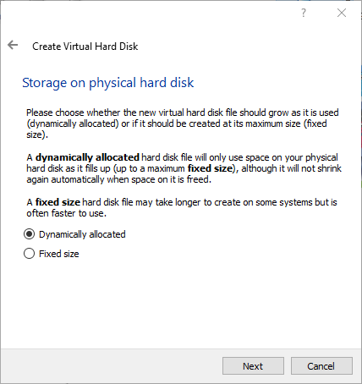
7. Name the file with an appropriate name. The disk size and location can be adjusted here, if the defaults are not desired. Click the Create button to continue.  
   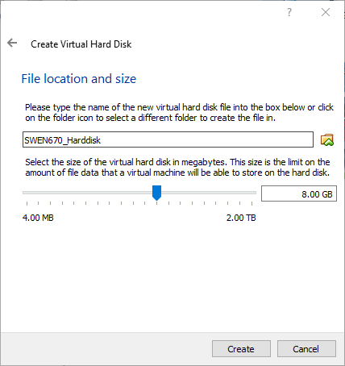
8. The VM should be created and Powered Off in the Machine Tools view.  
   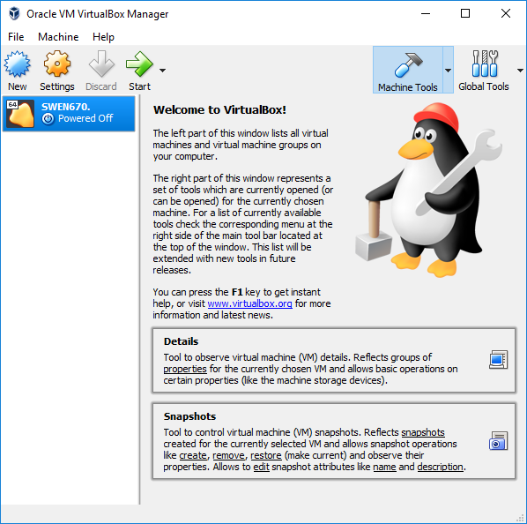

## Machine setting adjustments (Optional)

After the creation of the VM, a few settings could be changed for better performance and usability. These settings are optional.

1. Highlight the VM created in the previous steps and click the Settings button.
2. Under the System/Motherboard menu, the Floppy option can be unchecked. This is also where the memory settings to the VM can be adjusted after creation.  
   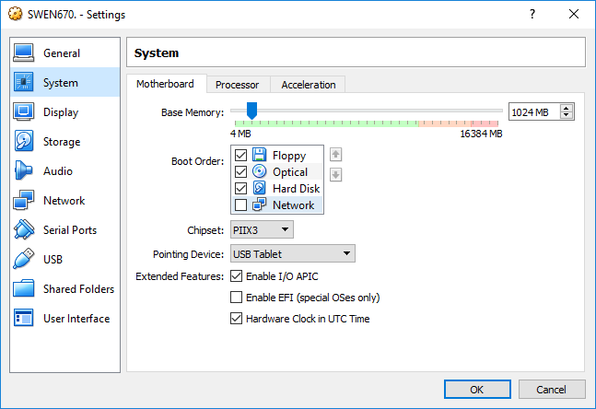
3. Under the System/Processor menu, the Execution Cap should be adjusted to 90%. This will prevent the VM from completely consuming CPU resources on the host machine, if it is CPU bound for an extended period. If the host machine’s BIOS supports it, the Enable PAE/NX should remained checked.  
   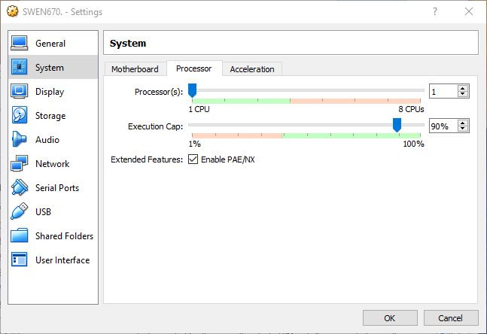
4. Under the Network / Adapter 1 menu, ensure the “Enable Network Adapter” is checked and change the Attached to: option to “Bridged Adapter”. The Name: field should populate. Select the host machine’s ethernet adapter. This will present the VM as a normal sperate system to the network the host machine is attached to.  
   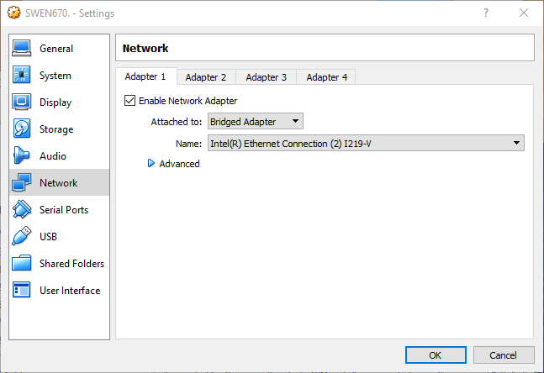
5. Other options can be selected, based on the needs of the host admin. The above settings are just recommendations for a VM which can support the CentOS-7 install for the SWEN670 course. Click the OK button when finished.

## Installing CentOS-7

The ISO image downloaded previously from <https://www.centos.org/download/> should be mounted to a removable medium. The steps below are designed to install to the previously created VirtualBox VM.

1. Highlight the VM and click the Settings button. Navigate to the Storage menu and click on the CD ROM icon to highlight the IDE Secondary Master setting.  
   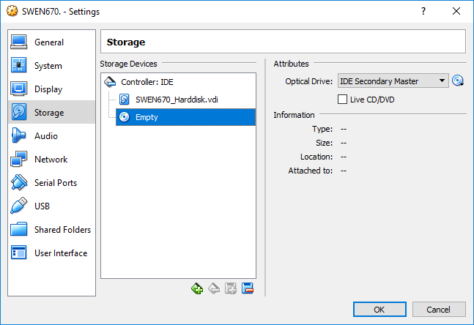
2. Click on the disc icon, just to the right of the IDE Secondary Master selection and select the Choose Virtual Optical Disk File. Find and select the downloaded ISO file. Click Open to return to the previous window.  
   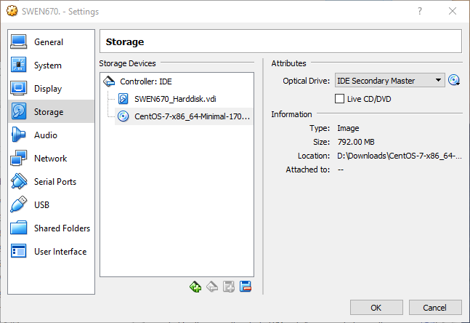
3. Click OK to return to the VirtualBox Manager window.  
   
4. Click the Start button. A new window will open  
   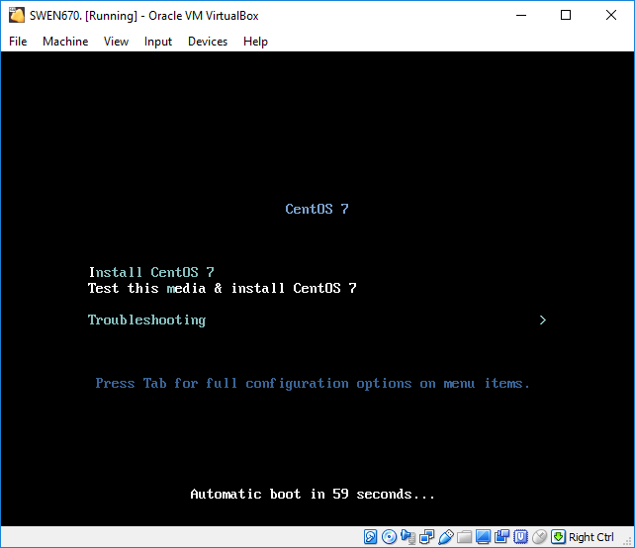
5. Press the Enter key to select the “Test this media & install CentOS 7” option. After a few minutes, the process will verify the integrity of the ISO image and launch the CENTOS 7 installer.
6. Select English from the left-hand menu and English (United States) from the right-hand menu. Click the Continue button to move forward.  
   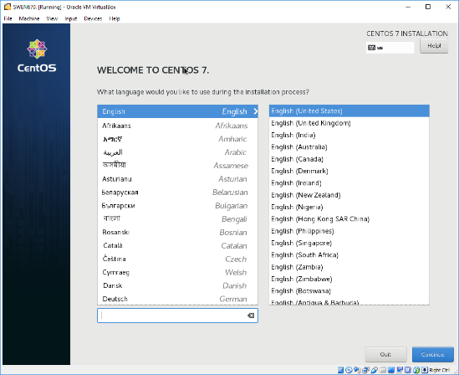
7. After a few moments, the next screen will stop updating and highlight that the INSTALLATION DESTINATION item needs to be completed. Click the INSTALLATION DESTINATION item.  
   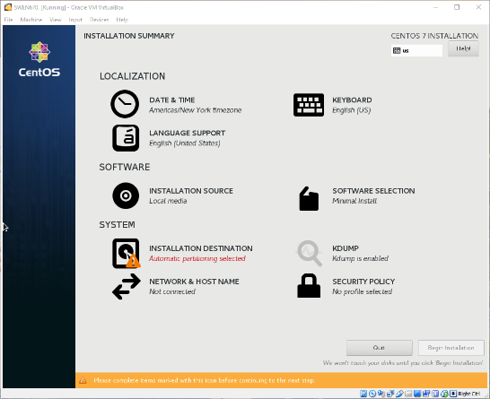
8. Click the ATA VBOX HARDDISK option twice and click the Done button at the top of the screen.  
   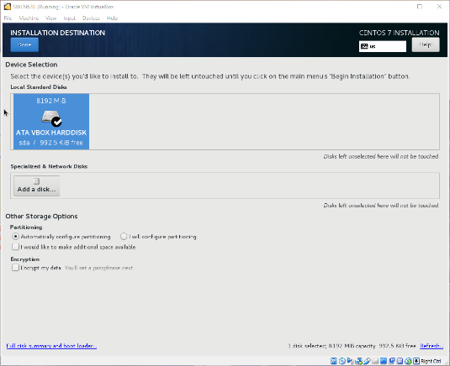
9. Click the network item. Turn ON the Ethernet connection at the top right of the screen. Network details will fill in as the system obtains an IP address through the network’s DHCP service. If a static address is desired, it can be configured here, or through a static lease type within the network’s router. Both are out of scope of this document. Click the blue Done button at the top of the screen when done with the network configuration.
10. If there are any additional items with a yellow warning icon, they will need to be resolved before continuing. Otherwise, click the Begin Installation button.  
    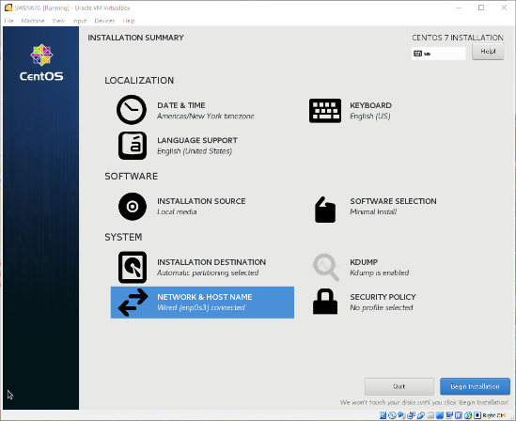
11. The installation will begin and can be tracked by the progress bar at the bottom of the screen. While the install is running, click the ROOT PASSWORD item.  
    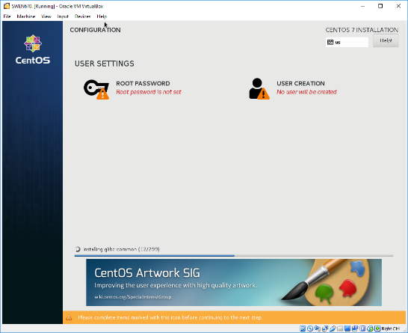
12. Set the root password. Do not lose this password. Click the Done button when complete.  
    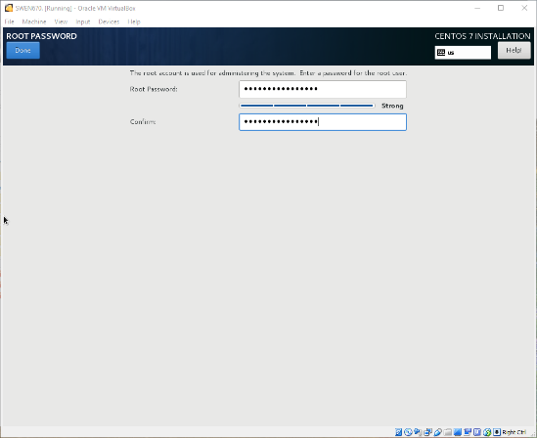
13. Click the USER CREATION item. Create a non-administrator user for the system. Click the Done button when complete.  
    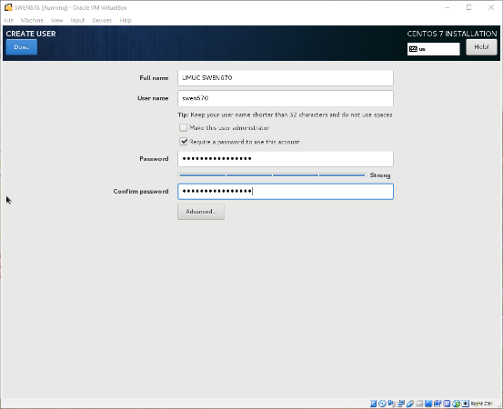
14. Depending on how quickly the root password and user creation is done, the installation process may not be finished; additional wait time may be required. When the installation process is through, a blue Finish configuration button will appear. Click that button to complete the install.  
    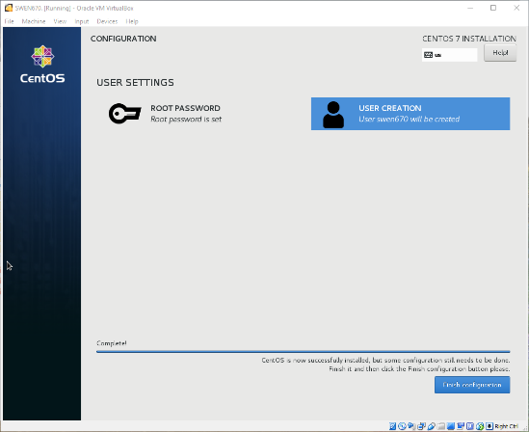
15. Additional configuration items will run. When they are complete, a blue Reboot button will appear. Click that button.  
    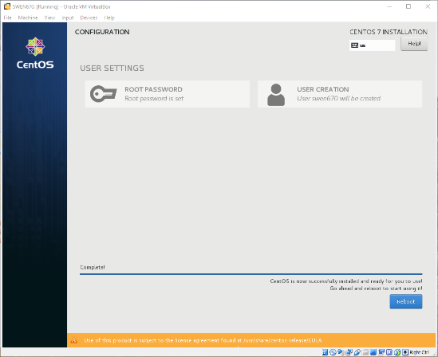

# Creating a wiki with Meza

Most of the documentation of Meza directs the commands to be run with sudo. As such, this guide will install Meza as root to maintain that compatibility. If it is undesirable to have MediaWiki running as root, please adjust as needed.

1. Ensure the VM machine is started and the console is displayed.  
   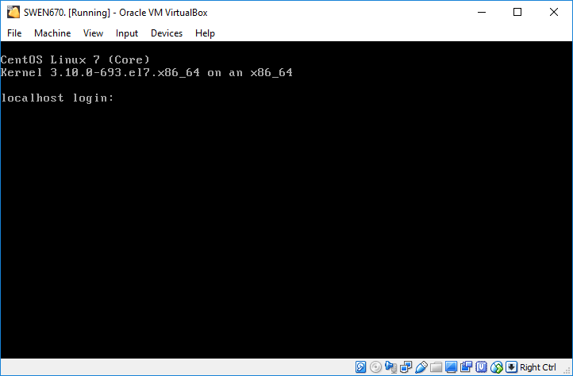
2. Log in to the system as root, with the password created during the CentOS installation.   
   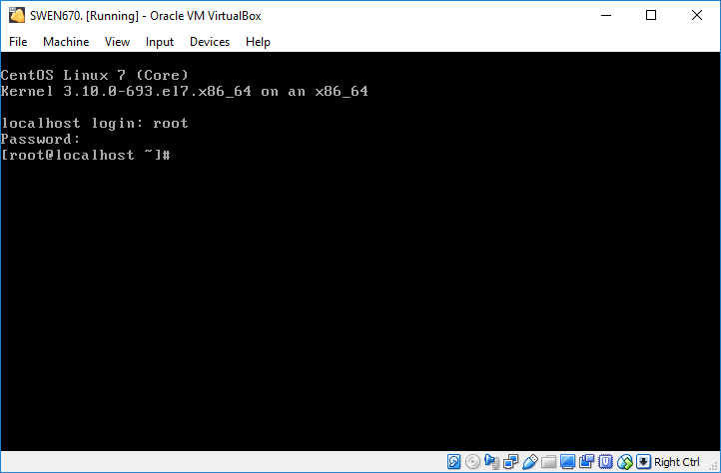
3. To install git on the system, run the command: yum install -y git  
   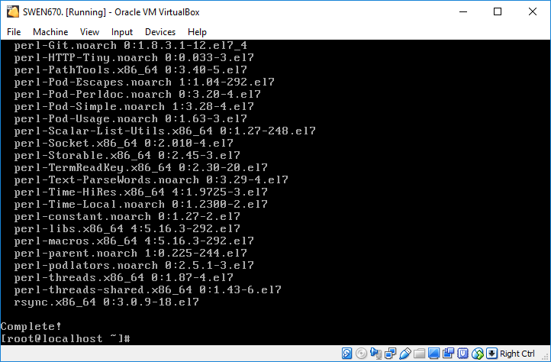  
   1. If the above command does not run, it is likely the system is not configured correctly on the network. It is suggested to google and any error message seen for additional troubleshooting help.
4. Pull a copy of Meza from the Git repository to the /opt/meza folder by running the command: git clone https://github.enterprisemediawiki/meza /opt/meza  
   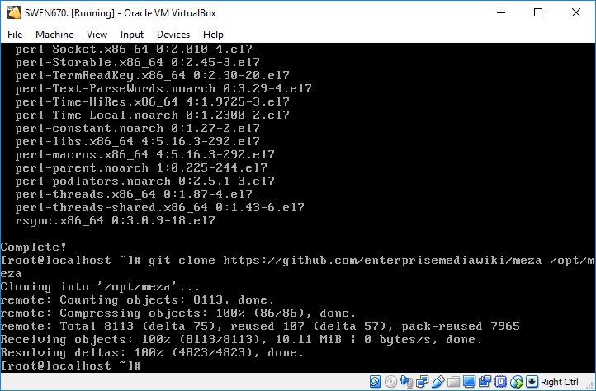
5. Load the Meza shell script which will pull all of the dependencies that Meza requires by the command: bash /opt/meza/sec/scripts/getmeza.sh  
   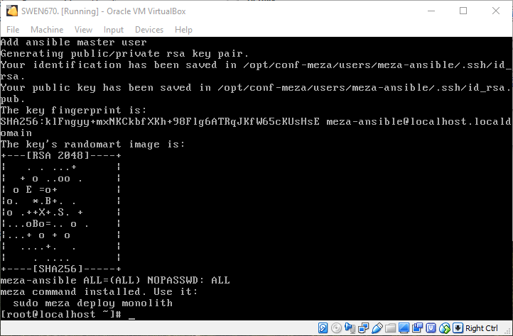
6. Run the following command to determine the IP address of the VM: hostname -I
7. Deploy Meza to an environment called monolith by running the command: meza deploy monolith  
   Use the IP address of the VM found in the previous step and optionally pick a database password to use.  
   The first time running deploy, the process could take up to 15 minutes to complete. If the screen goes blank, hit the down-arrow key to wake up the display again.  
   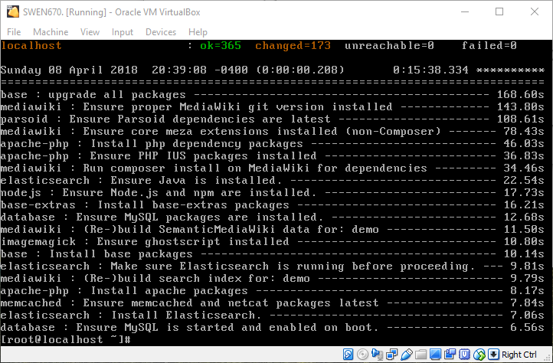
8. Open a browser on the host machine. Enter the address <https://IPADDRESS/> where IPADDRESS is the value found from the hostname -I command. If the browser warns about not being secure, this is due to Meza creating a self-signed certificate which is always considered a security risk. Accept the risk and proceed to the page.  
   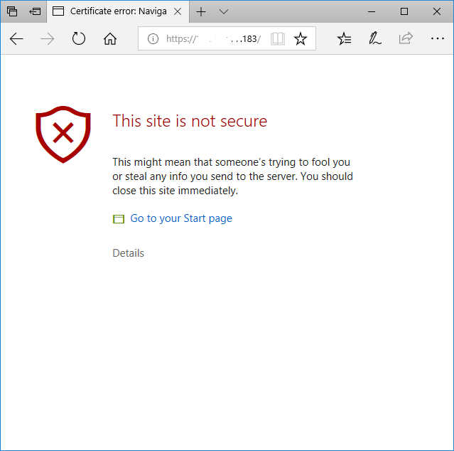
9. If all went well, the default Demo Wiki will be displayed. Congratulations, you have a working MediaWiki install provided by the Meza script.  
   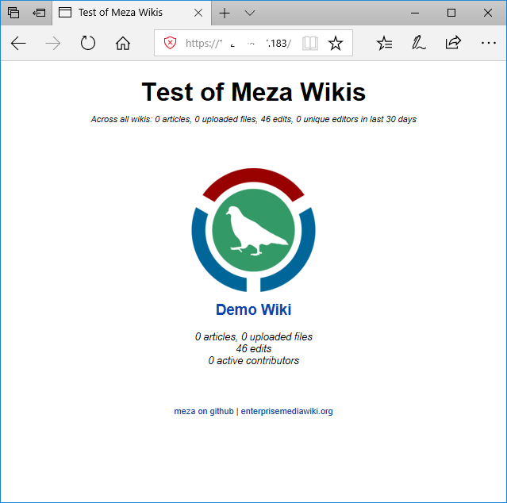

# Additional Tips

* After installing CentOS, consider the documentation at <https://wiki.centos.org/HowTos/Network/SecuringSSH> to secure shell access to the VM.
* With shell access configured correctly, the system can be connected to via the ssh port, instead of the console. As such, the VM can be started in Headless Mode, via the down arrow next to the green Start button in the VirtualBox Manager screen. This will start the VM, but without a console, to free up the host’s screen. Once the VM is started in Headless Mode, the VirtualBox Manager window can be closed without effecting any VMs running.
* By default, Meza will install over fifty (50) extensions as part of its core configuration. Additional extensions, such as the Gamification extension, can be included by editing the /opt/conf-meza/public/MezaLocalExtensions.yml file and running another meza deploy monolith command.
* If the VM is configured on a non-business class ISP account, the network will likely block a Mail Transfer Agent (MTA) from running, to prevent SPAM from being sent. The VM will still understand and accept Simple Mail Transfer Protocol (SMTP) commands, but the message will not forward anywhere. For the email verification game, use an email address of a valid shell users on the system (created earlier in this guide as swen670) @ localhost (e.g. swen670@localhost). The root user can then display the contents of /var/mail/swen670 to find the verification URL to use.
* If unfamiliar with Linux text editing programs, we suggest using nano which can be installed via: yum install -y nano
* If it’s forgotten, displaying the contents of /opt/htdocs/mediawiki/LocalSettings.php will show the database username and password, which can be used for direct mysql access.
* Additional documentation of Meza can be found at <https://github.com/enterprisemediawiki/meza> under the manual folder.